News Release – For Immediate Release

Endow a Book Impacts Students, Faculty at Kewanee Schools

The “Endow a Book” program of the Kewanee Schools Foundation received its second major donation from Dr. & Mrs. Thomas Marks ’65. The gift was large enough to provide much needed books and teacher resource materials for each school in District #229. The gift was given in honor of Tom’s parents Arthur and Virginia Marks. The foundation divided their gift proportionately among the schools in District #229 by enrollment.

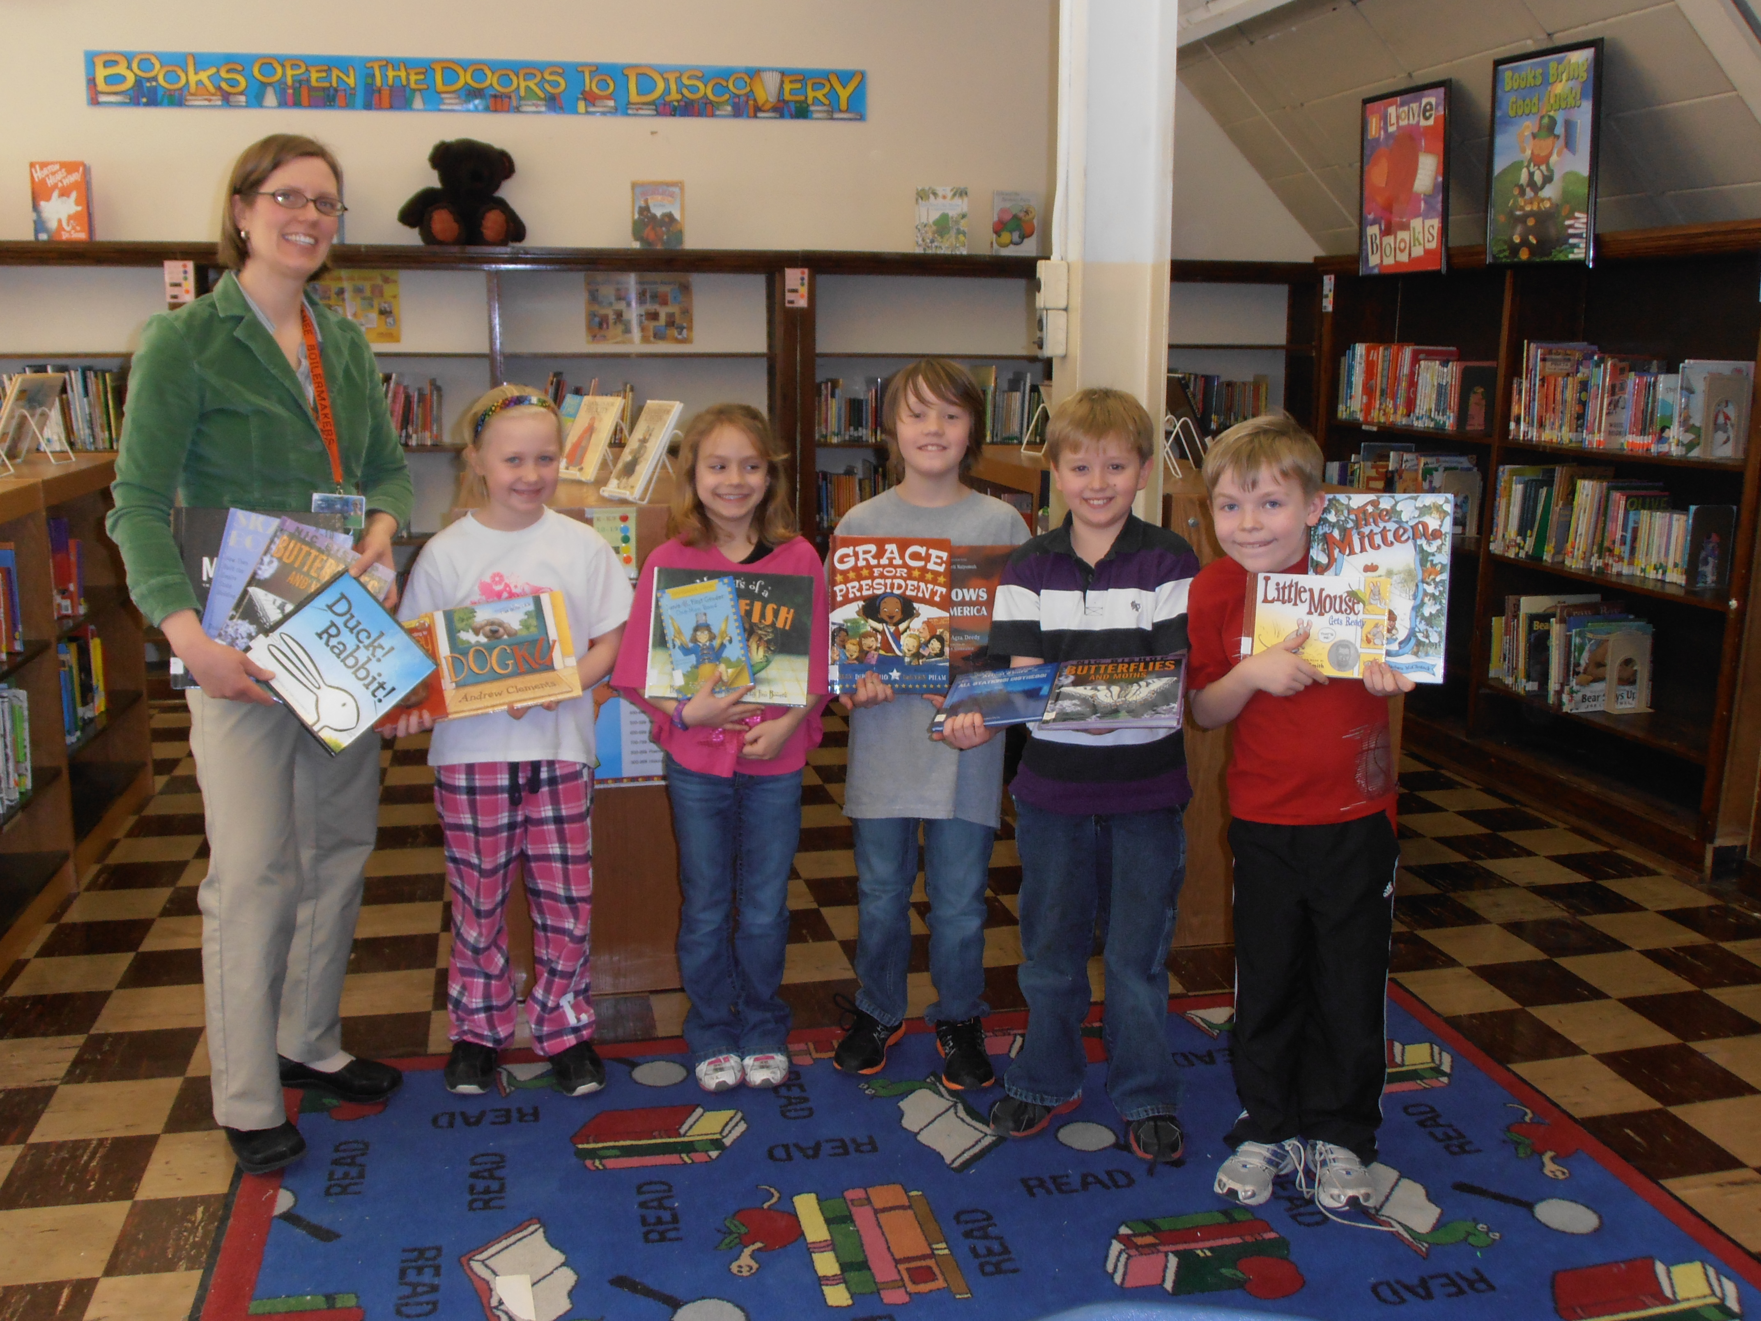

Pictured left to right: Irving School Librarian Ruth Kelley, Josie DeBord,
Kya Albach, Keeyan, Davis, Jake Brown, Gabe Johnson.

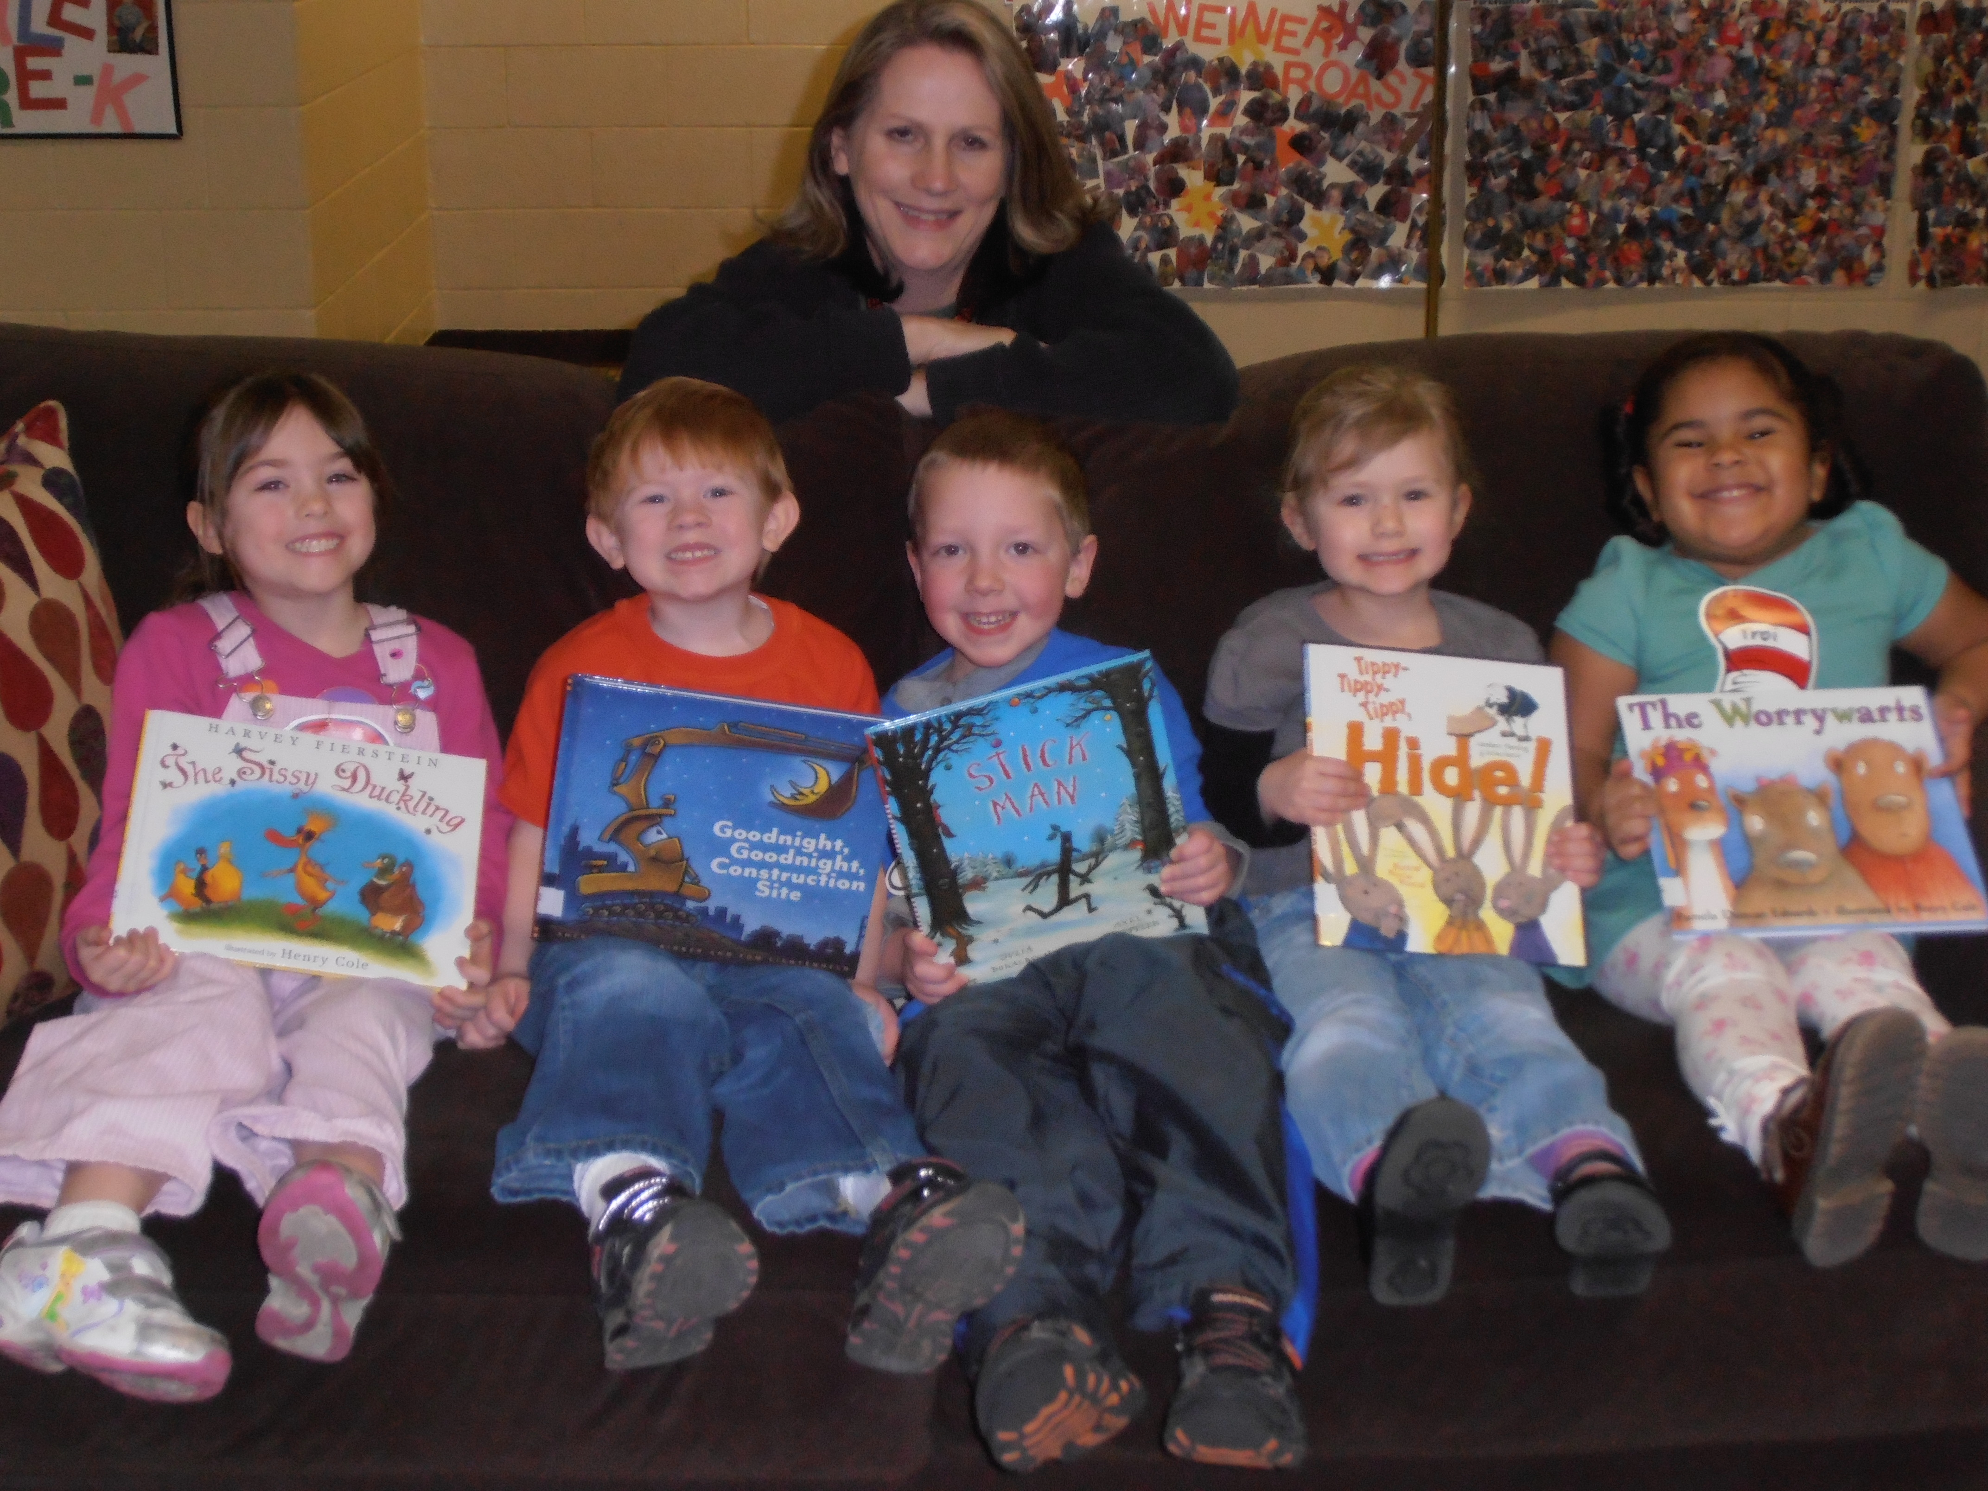

Pictured left to right: Lyle School preK students Kylie Vervynck,
Hunter Vancil, Aaron Zaiss, Emma Brants, and Troi Currie.
Back Karen Rogula.

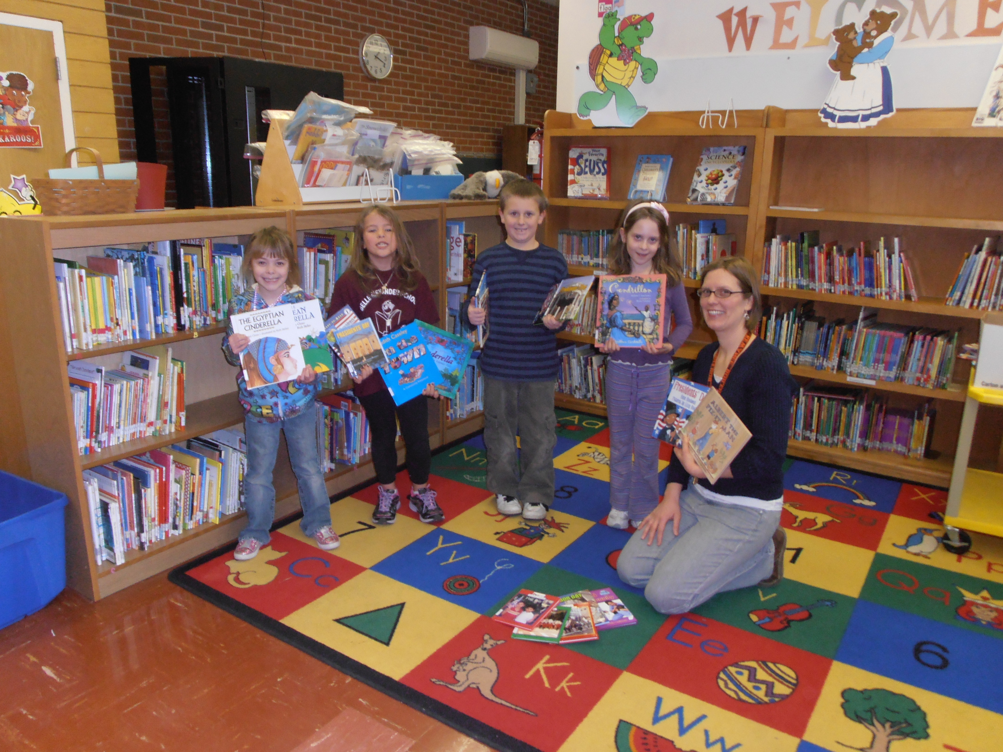

Pictured left to right: Belle Alexander students Heaven Pinnick,
Natalie Maxon, Blake Lambert, Audrey Kelley, and school librarian
Ruth Kelley

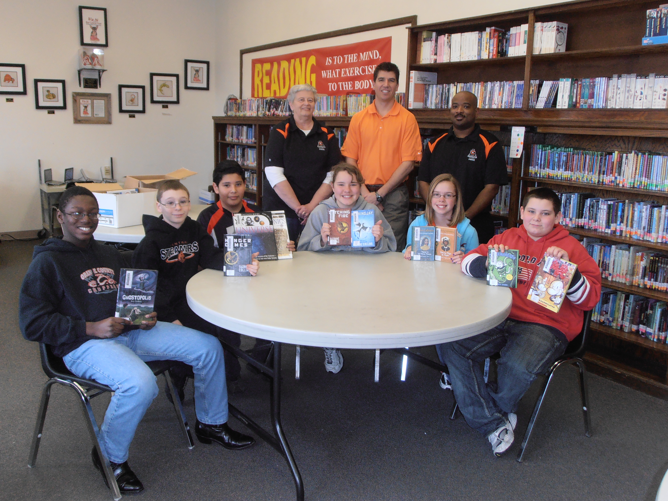

Pictured left to right: Central 6th grade students Depree Waugh, Collin White,
Nick Sierra, Katy Pritchard, Ally Kubiak, and Alex Karns.
Back row librarian Anne Koepke, Principal Jason Anderson,
Assistant Principal John Hinton.

